UCLAX-22W-CSX4501

Professor Ben

WK 4 Assignment

Fanny Jiang

Introduction to Data Science Gallery

Welcome to the class data viz gallery. Add your name in this document, and paste your data viz outputs from your class assignment as instructed.

## Ben Winjum

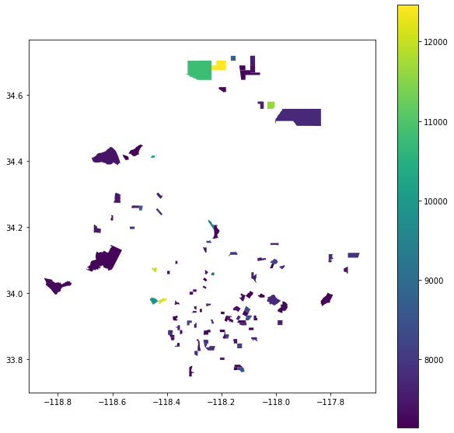

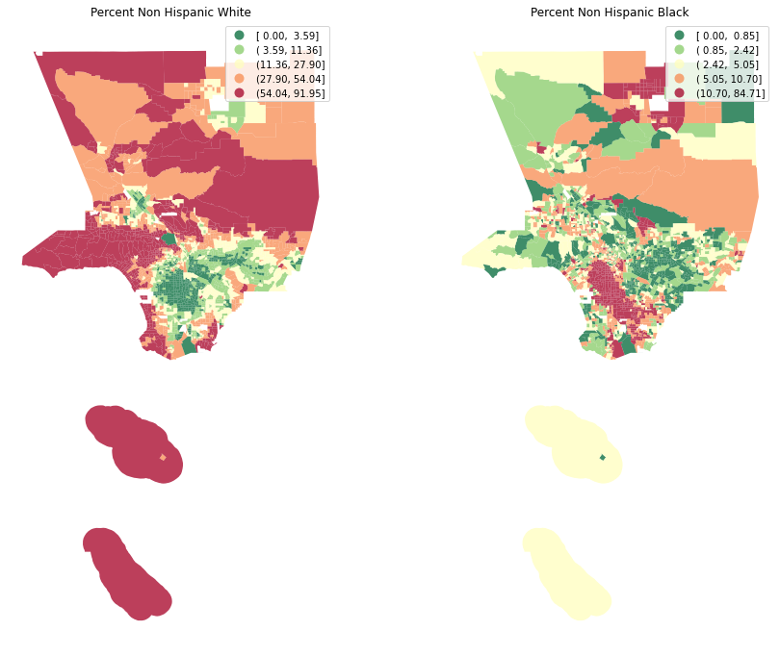

Census tracts with more than 90% Hispanic Population: